2016

*Results Uploading*

William Linton

Scout Software Engineering

**Table of Contents**

Introduction 3

Importing Data 7

Viewing Data that has already been uploaded 21

Managing folders and files 24

Using the context menu 24

Using the Folder Manager 27

# Introduction

The Results uploader allows Buxton employees to upload data for our clients to see. It will be visible in both SCOUT (to show on the map) and My Data (to show in the data grid). It is similar in format to Areas of Interest. The difference is that Areas of Interest is intended as a “junk drawer” for clients to put stuff that doesn’t fit into our database structure. Results is intended to hold the results of custom reports and studies conducted by Buxton employees such as USP Results.

In addition to uploading capability, Buxton employees can also add and delete folders, and delete and edit details for existing Results files. Clients cannot change anything related to Results – they can only view them.

At the moment, in order to upload Results, Buxton employees should log in to Internal Tools using their own login and impersonate a setup user belonging to the company they wish to upload data for. They should use the special “Import Data as…” link which will take them to the My Data Import Screen having logged in as the selected user.

*Note:* user account must be a setup user in order for the Buxton Results import option to be available.

**Getting to the Results Uploader**

1. Log in to tools.buxtonco.com (or tools-*.buxtonco.com depending on your environment)
2. Click Platform:

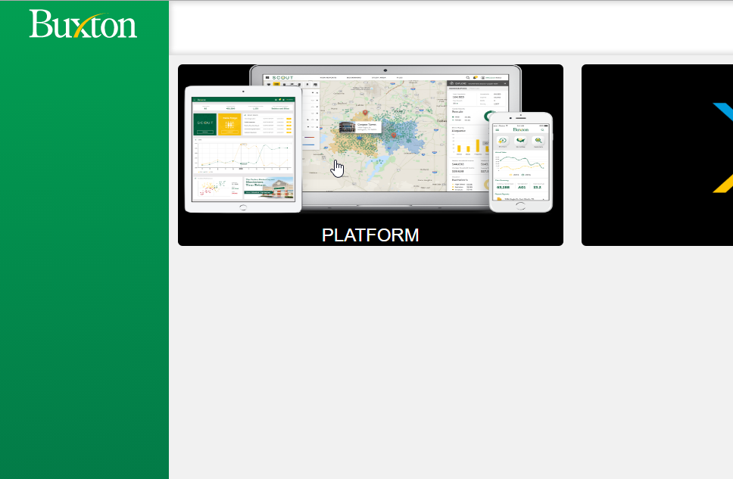

1. Search for and click the company you want to upload for: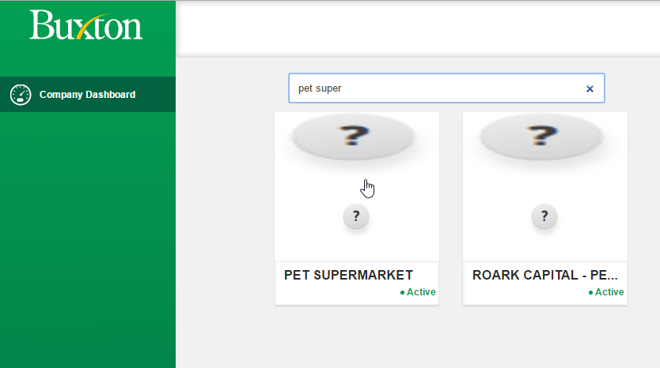
2. Click Manage Users:

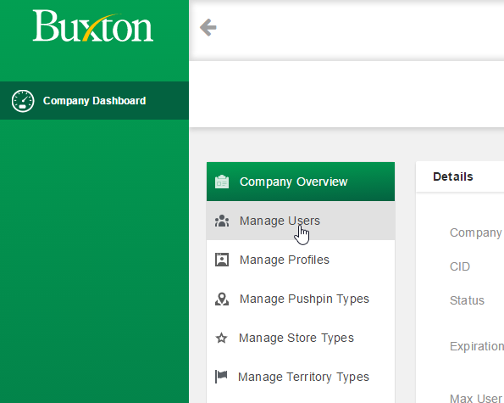

1. Find a user who is a **setup user**:
   1. At the moment, a user is a setup user if their username ends with “-setup”.
2. Click the “Import Data as” button for that user: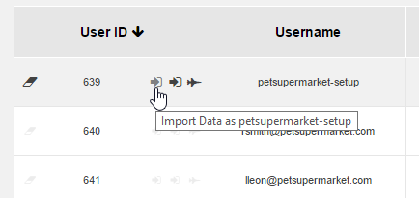
3. After a few moments, the My Data app should appear in a new window with the Import screen showing: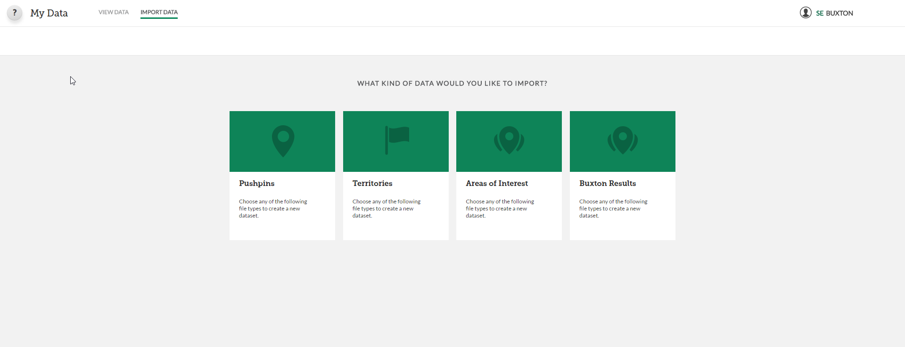

## Importing Data

1. On the Import screen, you should see several options for importing, including “Buxton Results”: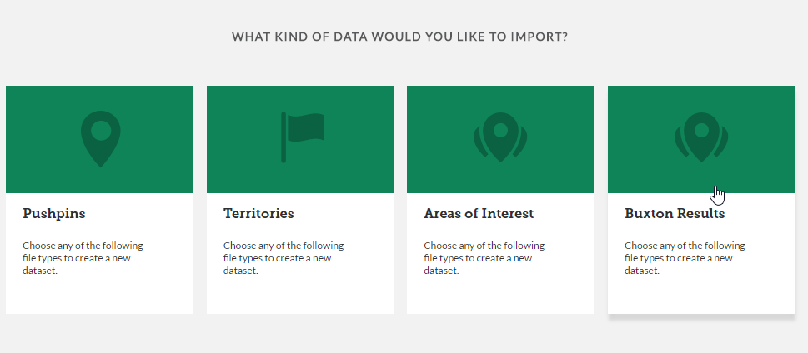
   1. Areas of Interest can be uploaded to by clients.
   2. Buxton Results are reserved for data that only Buxton can upload and are intended for things like USP results.
   3. If you don’t see Buxton Results, make sure the user account you’re using is a setup user.
2. Click Buxton Results:

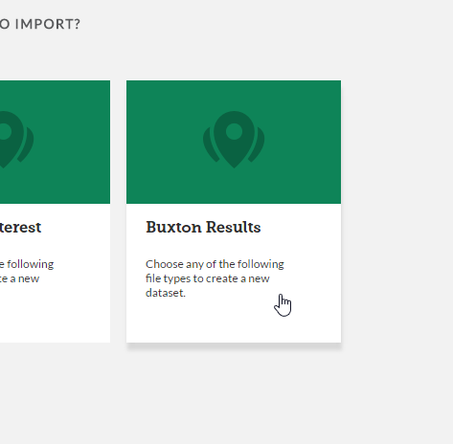

1. Select points or polygons depending on what type of data your file contains: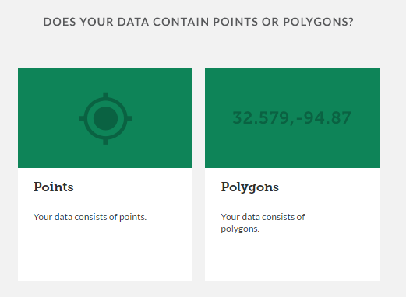
2. If you selected points, you will be asked whether your data is in Latitude/Longitude format, or whether you provided addresses that will need to be geo-coded: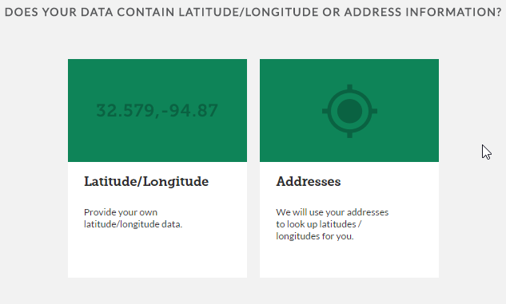
   1. If you select Addresses, the My Data app will attempt to geo-code all addresses for you. If a row’s address is successfully geocoded, latitude and longitude columns will be added to the file and will be used when rendering on the map in SCOUT. ***If your file already contains latitude or longitude columns, they will be overwritten***. If a row’s address cannot be geocoded, the row will remain in the file but will not show up on the map.
   2. If you select Latitude/Longitude, your data won’t be changed. These columns will be used to display the data on the map in SCOUT.
3. Use the folder dialog to navigate to the folder you want to upload into: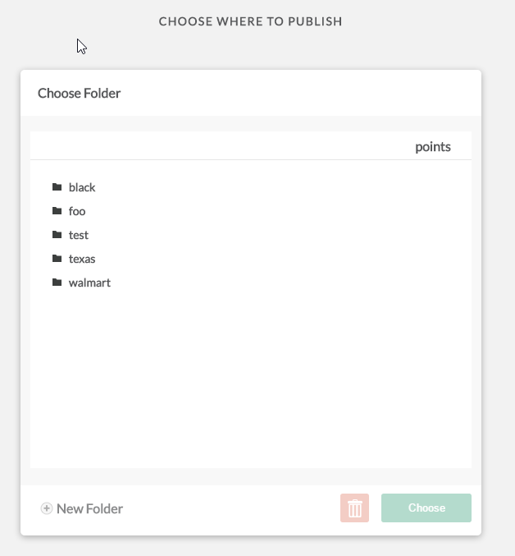
   1. Click a folder name to open it.
   2. Note that you are not allowed to upload into the root folder – you must select a sub-folder.
   3. To delete a folder, open the folder and click the delete button: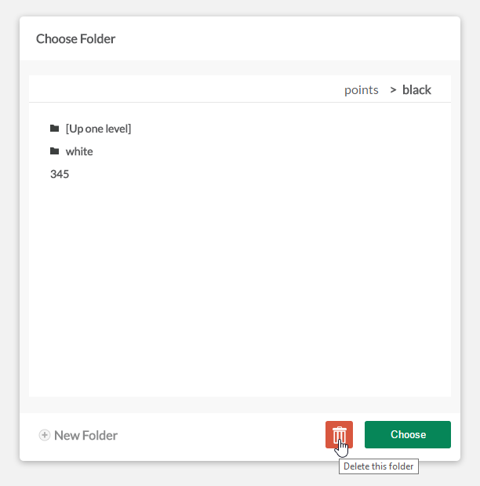
   4. To create a new sub-folder under the current folder, click the New Folder link: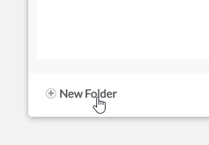
   5. The folder hierarchy you are currently in is shown in the breadcrumbs near the top of the dialog. You can click a folder higher in the hierarchy to navigate back to it: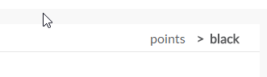
   6. *Note:* depending on whether you are uploading Point data or Polygon data, the folders will be different as there are distinct folder structures for each data type.
   7. Once you are in the desired folder, click Choose to proceed.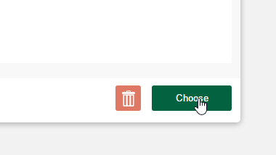
4. Type a name for the data – this name will appear in listings in SCOUT and My Data. When you upload your file, the actual filename will be discarded and the name you type here will be used to identify it:

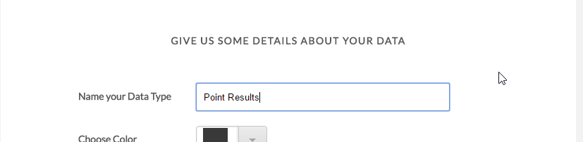

1. If you selected polygons, choose the color. When viewing the data in SCOUT, the polygons will display with this color on the map. *Note:* they will be slightly transparent, and since the underlying map features will have their own colors, the actual resulting color may appear slightly different:

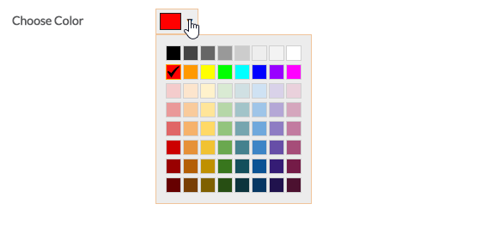

1. If you selected points, choose the icon color. When you change the color, it updates the icon’s color as well:

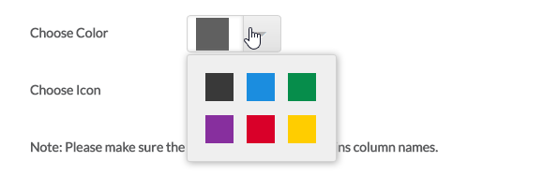

1. If you selected points, choose the icon:
   1. You can page through the list of icons by clicking the First, Prev, Next, Last, and numbered page links: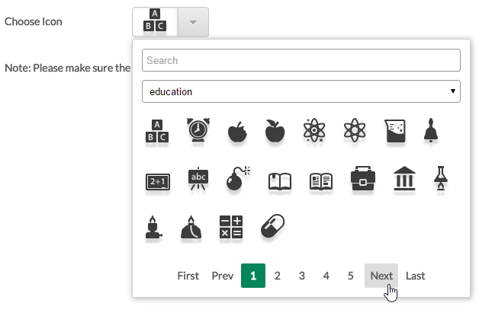
   2. You can filter the icon list by category: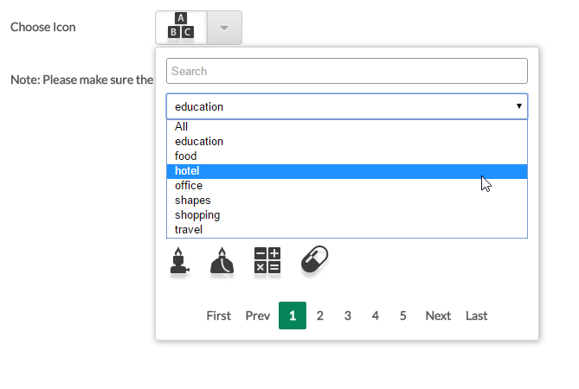
   3. You can also type a keyword in the search box and it will only show those icons matching that keyword within the current category: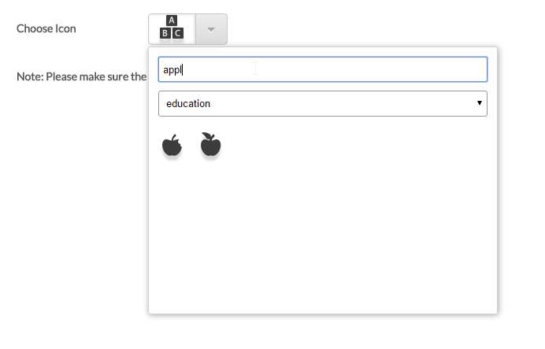
   4. If you want to search all icons regardless of category, change the category to All: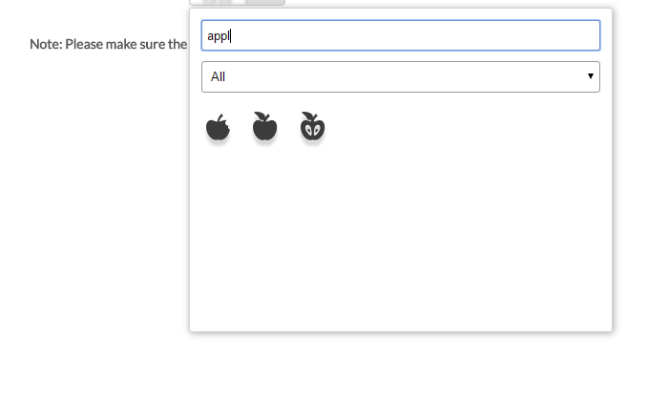
   5. Click an icon to select it:

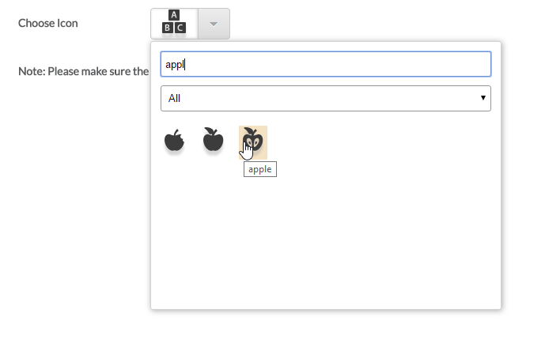

1. Once a name is provided, you can upload a file:
   1. Either drag a file onto the drop area:

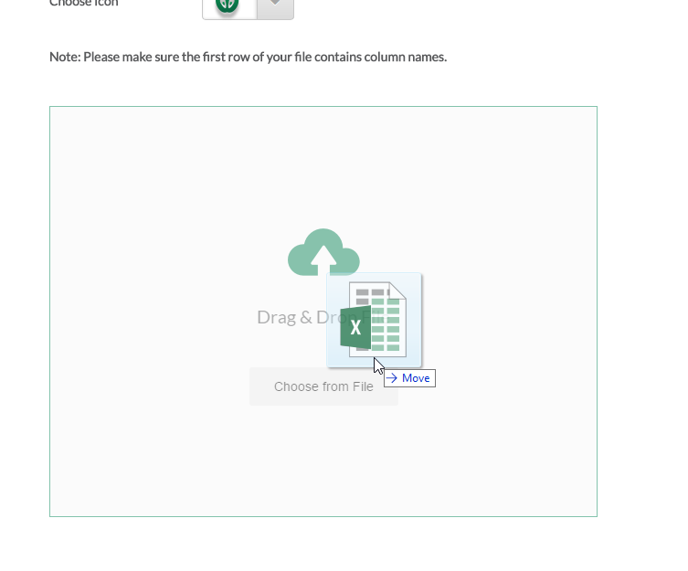

* 1. …Or click the “Choose from File” button to browse your computer for the desired file: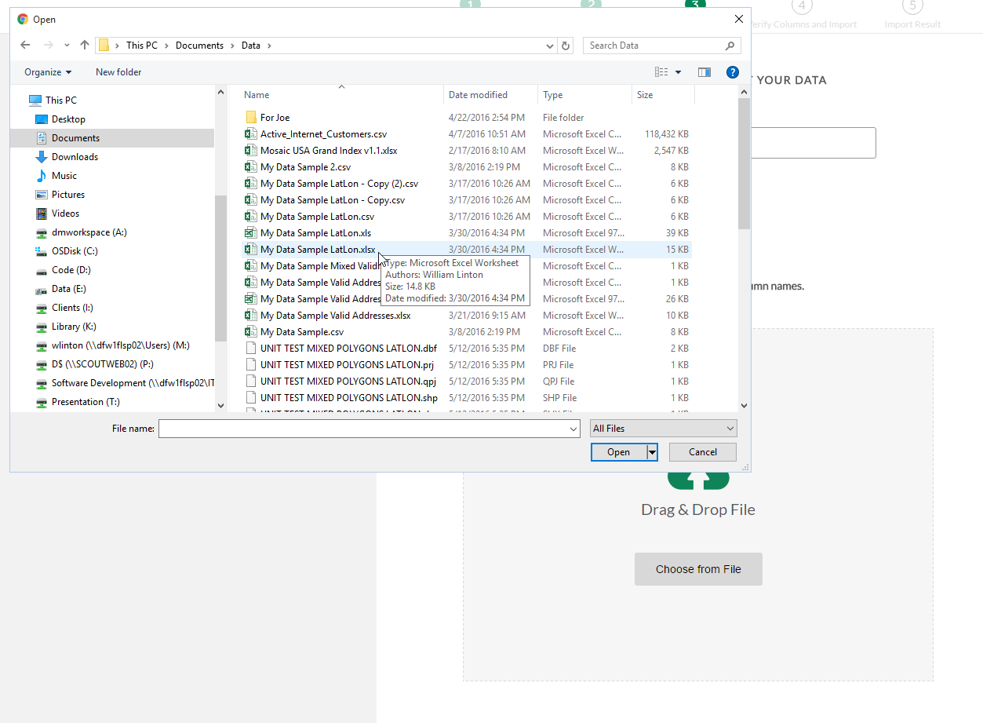
  2. *Note:* If you click “Choose from File” (which brings up an Open file dialog) and then drag a file the Open file dialog into the file drop area, this may crash your browser: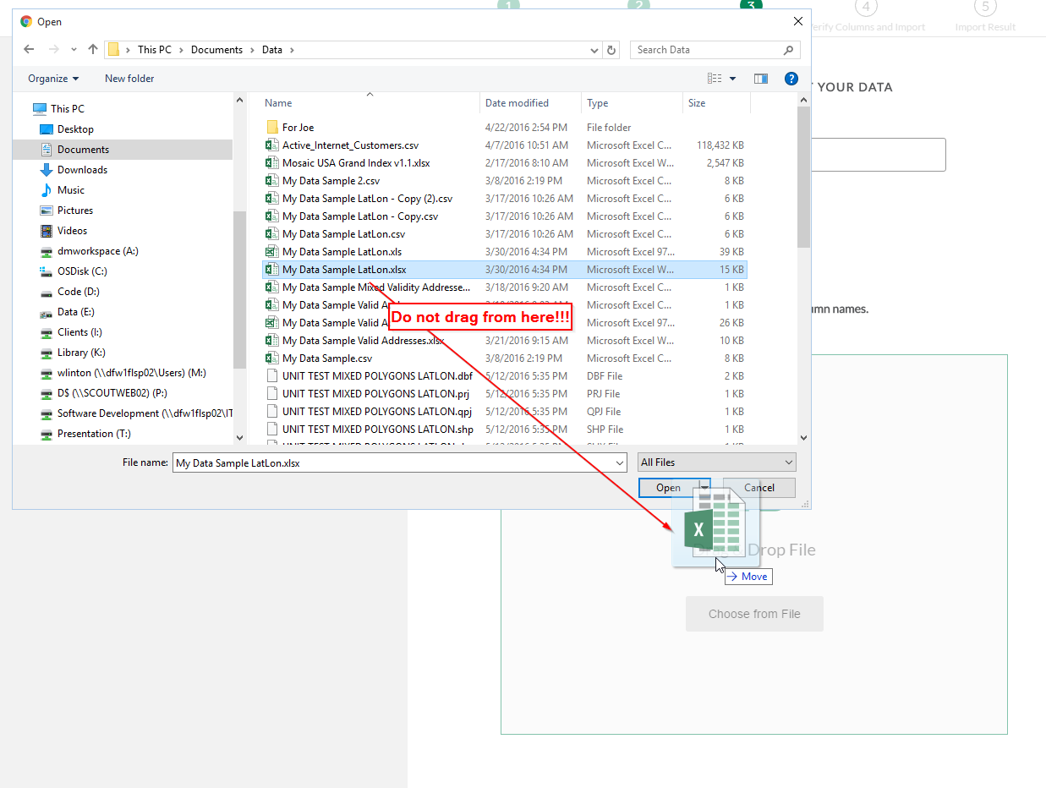
  3. If you click “Choose from File”, please make sure to use the Open File dialog to select the file, by either double-clicking the file from within the dialog, or selecting the file and clicking Open from within the dialog: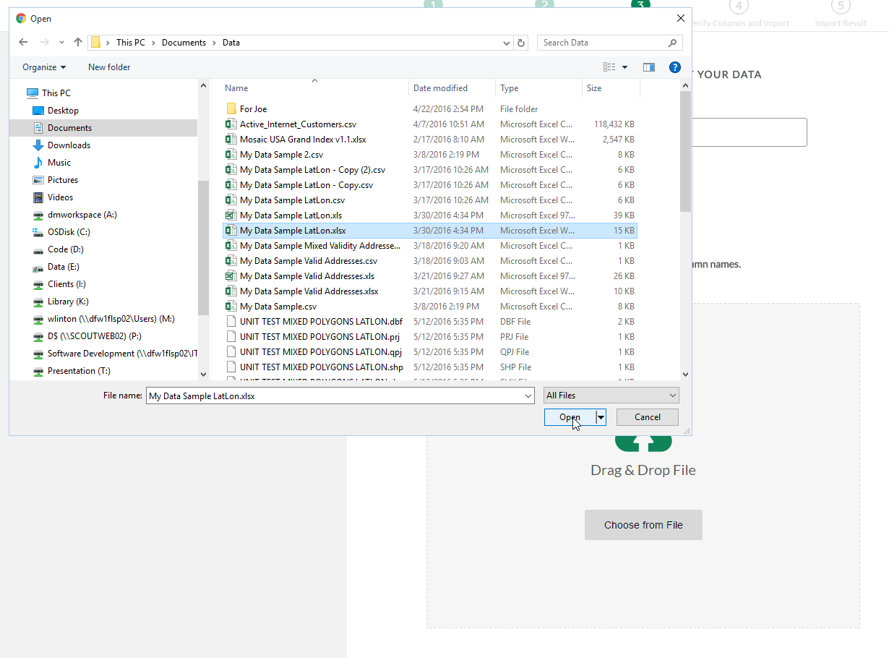
  4. Point file types can be in XLS, XLSX, or CSV format:
  5. Polygon file types must be in ESRI Shapefile format and zipped up in a single .zip file: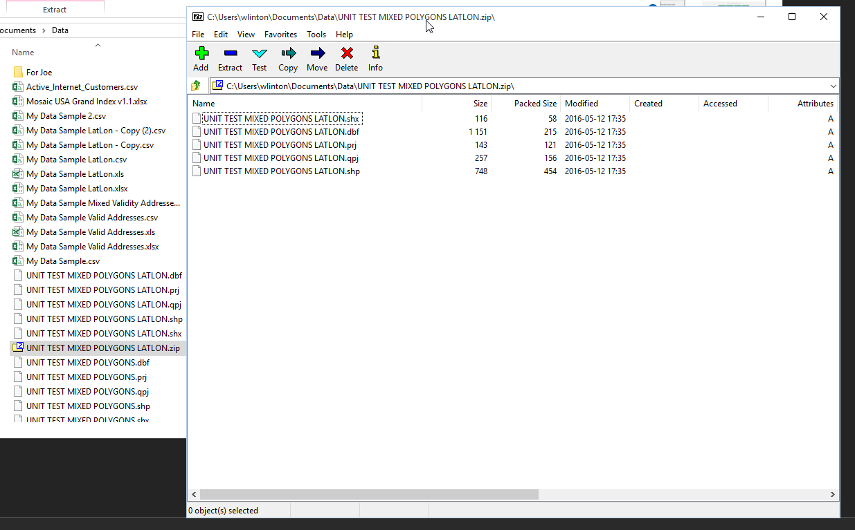
     1. A polygon zip file must contain at least a .shp and a .dbf file. The other shapefile extensions are optional.

1. When you upload the file, My Data will try to detect the columns contained in the file:
   1. If the file type is wrong, or if the file cannot be opened, or if there is a basic problem with the file, a message describing the issue will show in the file drop area: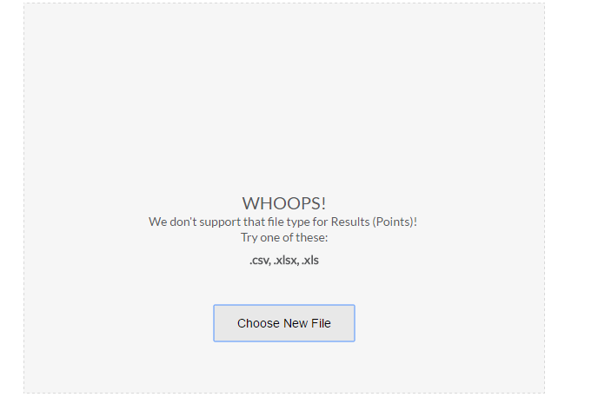
   2. If an error message appears, simply correct the problem and upload the file again as in step 10.
2. If My Data successfully found the file’s columns, a screen will appear allowing you to assign columns. Basically, this means that My Data has certain columns that it expects to find. Instead of forcing you to name them a certain way, My Data lets you tell it which columns are which.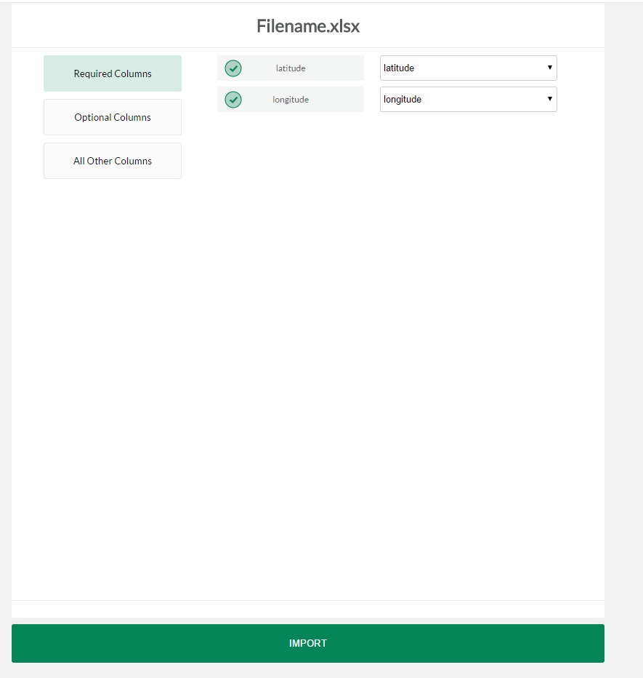
   1. For Buxton Results (and Areas of Interest), the actual underlying file will remain the same as when you uploaded it. When you view the data in My Data’s View Data tab, it will show with the original columns from your file. However, SCOUT will know which columns you assigned and will use them for certain things, such as where to draw them on the map.
3. Click Required Columns. A list of columns appears: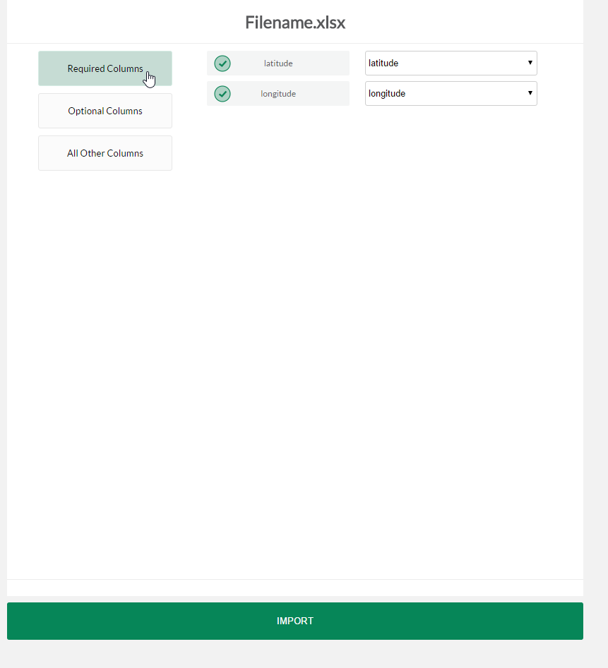
   1. For each column, the name on the left describes what My Data expects to find.
   2. The drop-down box on the right contains a list of all the columns in the file that you uploaded. Select the column that you want to be used for this required column. For example, if you named your latitude column LATITUDE_MM, select LATITUDE_MM in the drop-down next to “latitude”: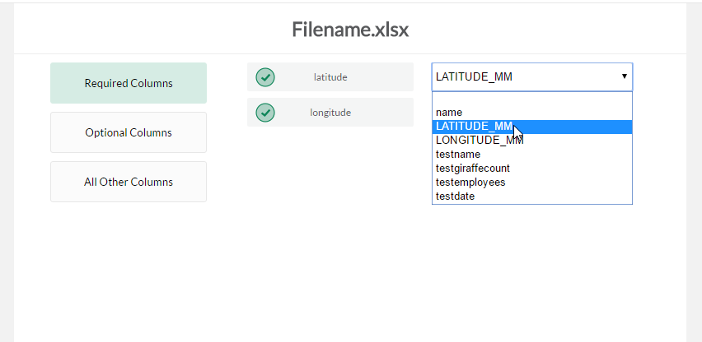
   3. When a column has been successfully assigned, a green checkmark will appear by the column’s name:

importing - 13c

* 1. In order to proceed, all required columns must have a corresponding assigned column.
  2. There are no required columns for polygon data.

1. Click Optional Columns. A list of columns appears. Any, all, or none of these can be assigned: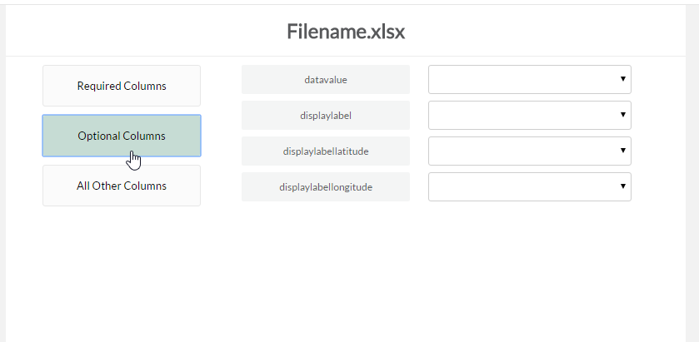
   1. My Data recognizes some optional columns for polygon data only:
      1. displaylabel – The text that will show on the map over the polygon.
      2. datavalue – The data that will be used to render a file as a thematic. (SCOUT also allows users to display this next to the display label separately, so this should be reserved for data only, no text.)
      3. displaylabellatitude – The latitude for a custom coordinate over which to center the display label. If not provided, SCOUT will calculate the centroid of each polygon automatically which can slow down rendering. To increase the speed at which polygons display on the map, provide a custom latitude/longitude.
      4. displaylabellongitude – The longitude for a custom coordinate over which to center the display label. If not provided, SCOUT will calculate the centroid of each polygon automatically which can slow down rendering. To increase the speed at which polygons display on the map, provide a custom latitude/longitude.
   2. There are no required columns for point data.
2. Click All Other Columns. All columns are listed that you have not already assigned. These will all end up in the destination file: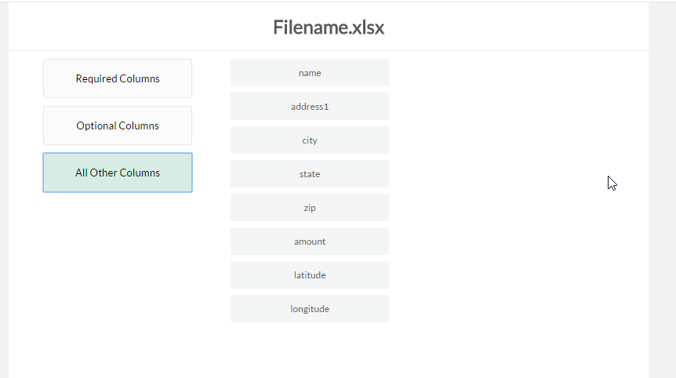
3. Verify all columns look ok, then click Import: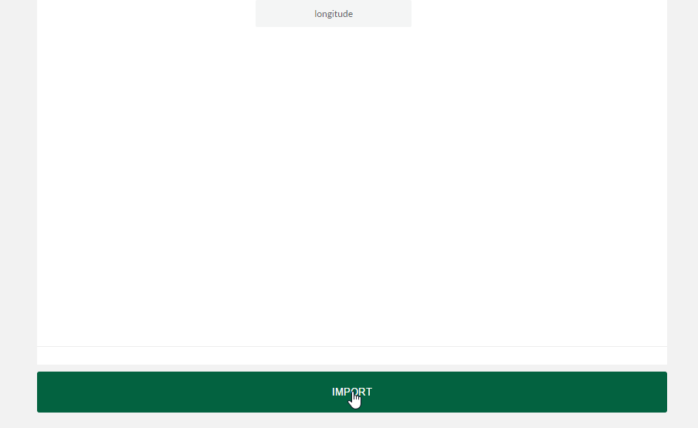
4. The import process may take a few moments and will display a loading screen: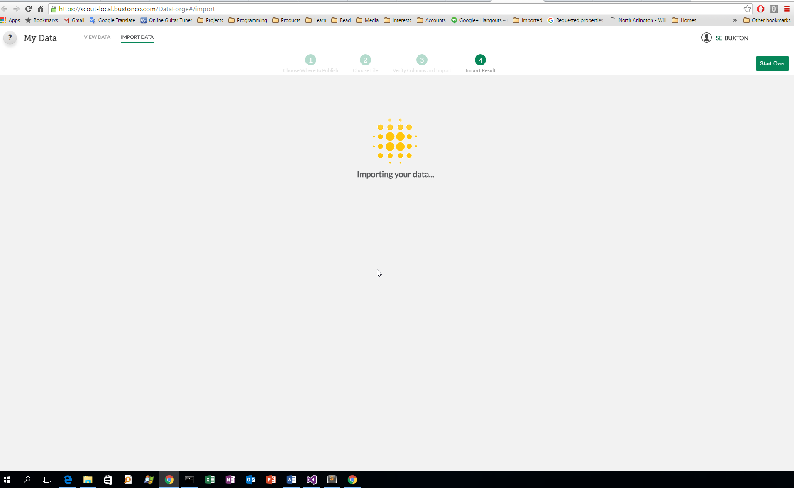
5. When the import is finished, a result screen will show.
6. If the result screen shows Success, this means that the file was uploaded. The number of rows imported and rows failed will also appear. If a row failed, it means it was either invalid or could not be geo-coded. For Buxton Results and Areas of Interest, the row will still be in the file if you export it later. 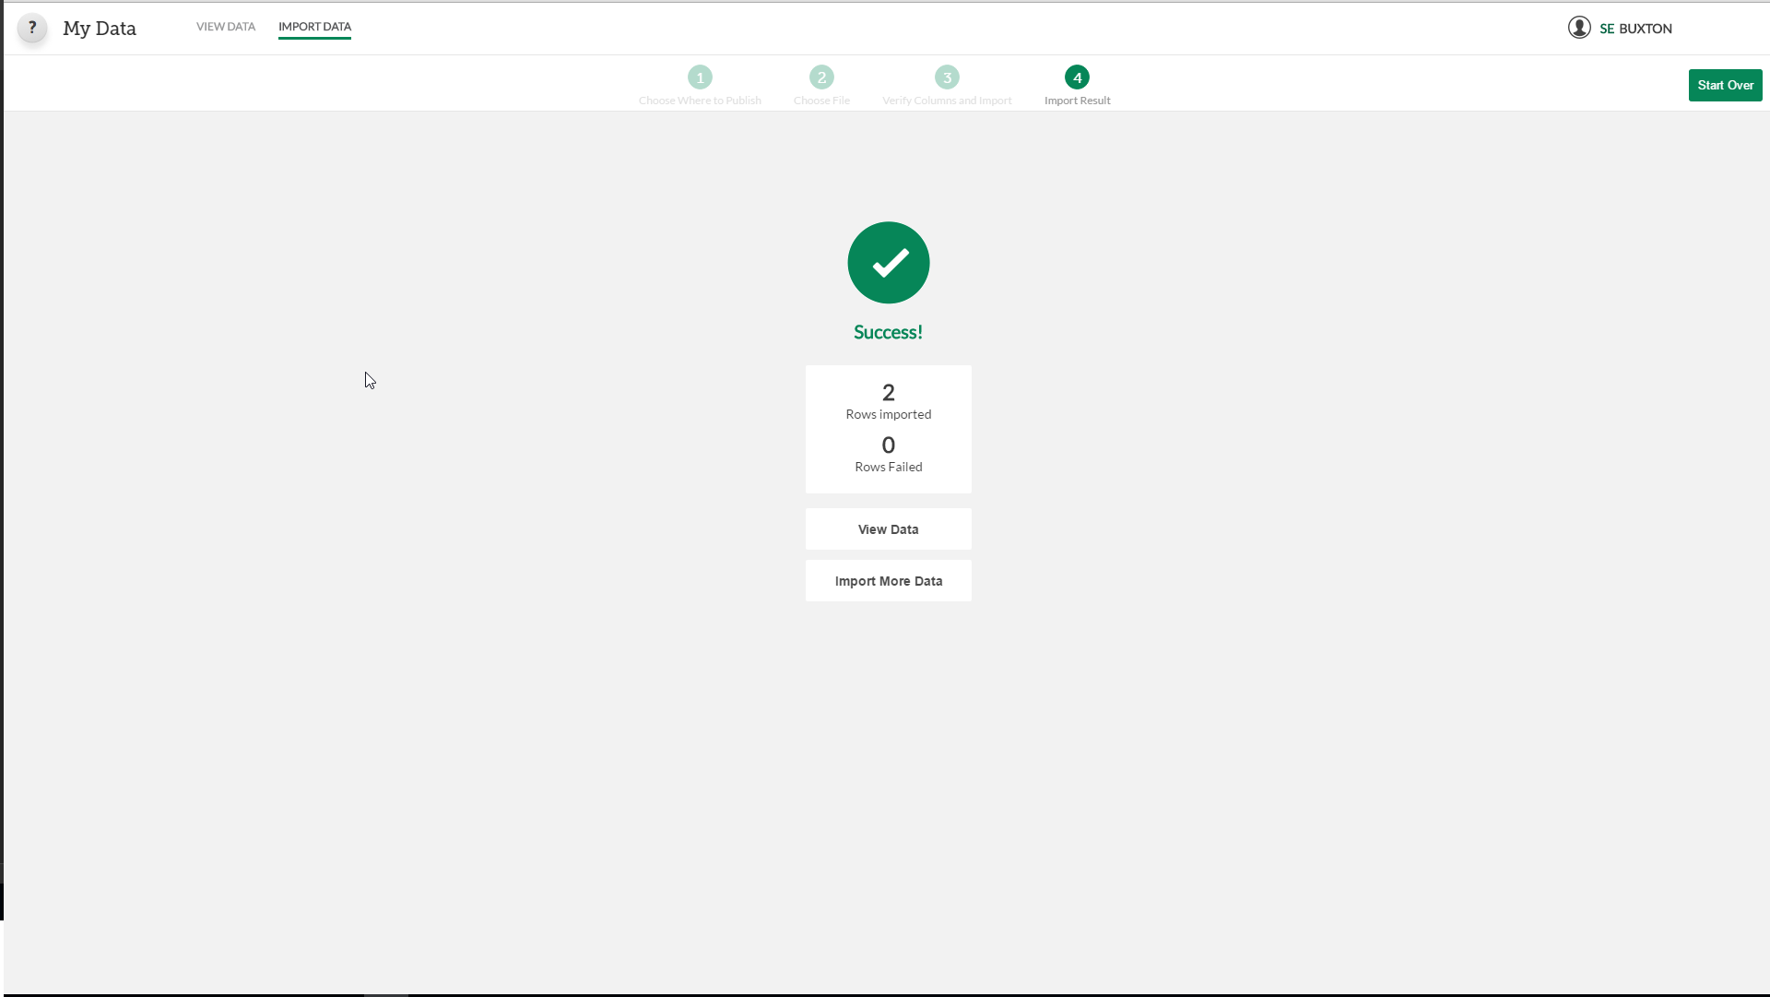
   1. If you want to import more data, click Import More Data.
   2. If you want to view the data that you just uploaded in the data grid, click View Data.
7. If the result screen shows Failure or Error, this means that something went critically wrong and that the file was not uploaded.

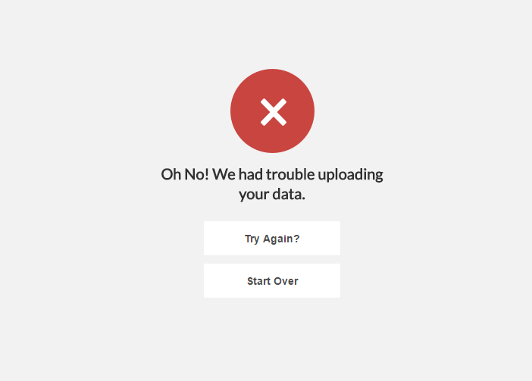

* 1. If you click Try Again, My Data will take the same file, the same column assignments you made, and the same name/color/icon and try to import again. This might help if the failure was due to a circumstance beyond our control: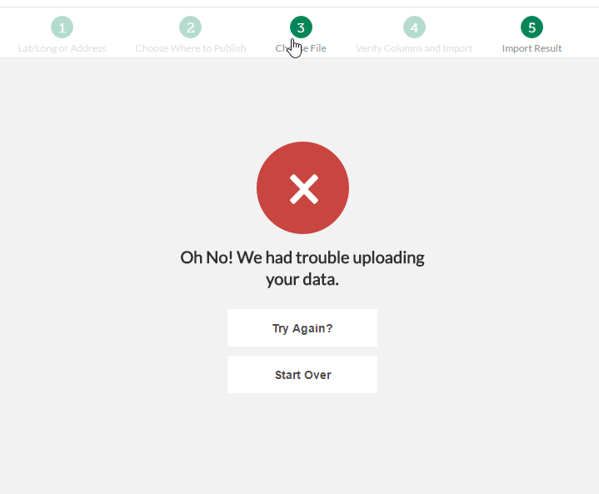
  2. But if there is something wrong with the file itself, Try Again will not make a difference – you will need to click the Choose File button from the progress panel at the top, or click Start Over, to try again.

## Viewing Data that has already been uploaded

1. Click View Data:

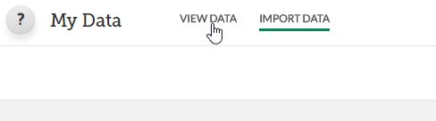

1. Click Results:

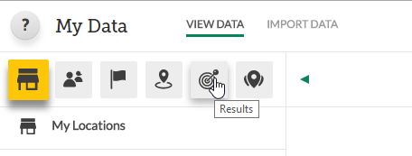

1. Click Points or Geographies, depending on the type of data you’re looking for: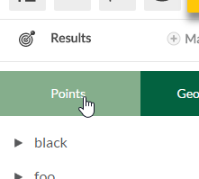
2. Folder names appear with black triangles to the left. Click the name to expand the folder: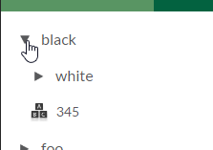
   1. Note that if you’ve just opened the app, the folders may not have been loaded yet. If no folders show beneath the Points and Geographies tabs, wait a few moments and they should appear.
3. File names appear under the folder names:

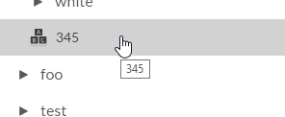

1. Click a file to view its contents in the data grid: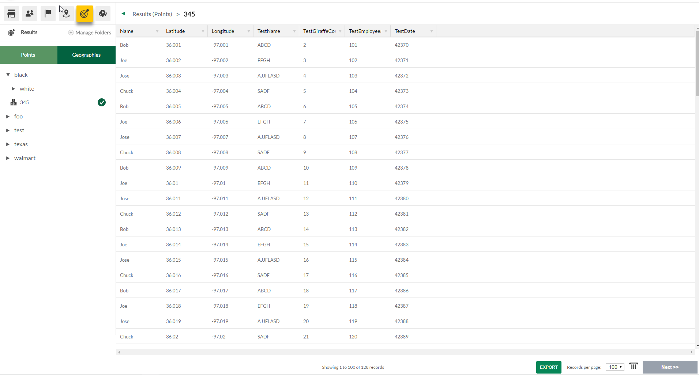
   1. Note that viewing a polygon file will show the extra data associated with each polygon, but will not show the actual polygon spatial data.
2. The data grid shows 100 rows at a time by default: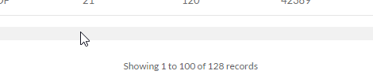
   1. To increase this number, select the desired number of records from the drop-down, or click the Next >> and Previous << links to page through the data: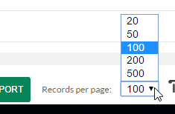
   2. Note that if the file is very large, it will take a long time for the data to display in the grid. For pushpins, stores, customers, and territories, decreasing the page size will decrease this time. However, for Buxton Results and Areas of Interest, decreasing the page size won’t help. Also, large data sets will cause a much bigger delay in Buxton Results and Areas of Interest than they will in the other data types.
3. Click the Choose Columns button to select which columns display in the grid: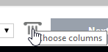
   1. Click a column to turn it on or off:

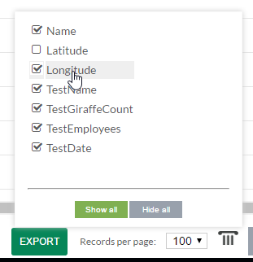

1. Filters are not supported for Buxton Results or Areas of Interest.
2. To download the original file, click the Export button:

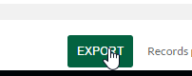

* 1. You will be asked which file type you want to export as. At the moment, exporting Buxton Results or Areas of Interest simply downloads the original file, so there will only be one file type choice: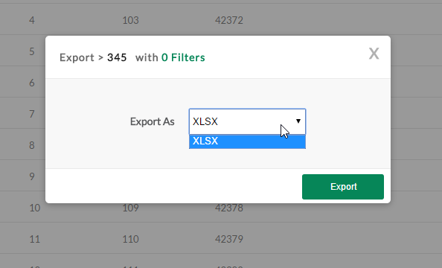
  2. Click Export to download the file:

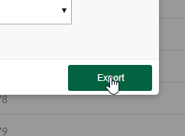

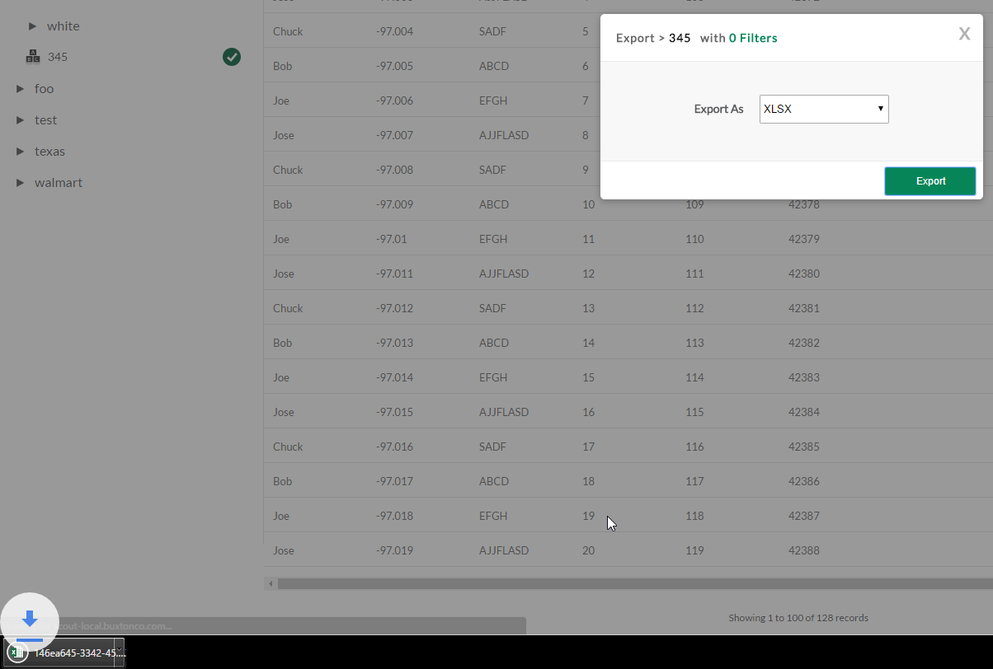

## Managing folders and files

Folders can be managed during the “Choose Where to Publish” import step during uploading (see above for details). Both files and folders can be managed from the View Data tab – make sure you click the Results button.

## Using the context menu

### Deleting a folder with the context menu

1. Right-click the folder name in the folder tree and click Delete Folder.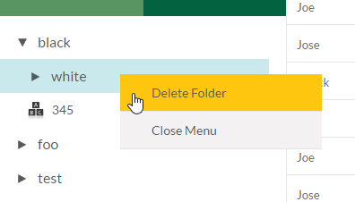
2. My Data will ask you if you’re sure you want to delete the folder. If the folder is not empty, it will also remind you so:

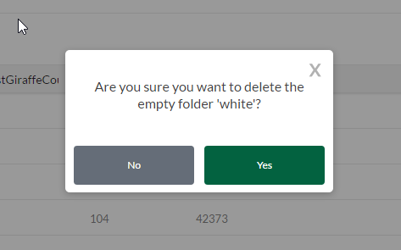

1. If you don’t want to delete the folder, click No.
2. If you do want to delete the folder, click Yes:
   1. Note that all sub-folders and files contained in this folder will be deleted too.
3. After clicking Yes, the dialog disappears and My Data deletes the folder, but it will take a few moments for the folder tree to update.
4. Note: If you select a file to show it in the data grid, and then delete a folder which contains that file (or contains other folders that contain that file), the data grid will not be emptied automatically after deleting the folder.

### Deleting a file with the context menu

1. Right-click the file name in the folder tree and click Delete File: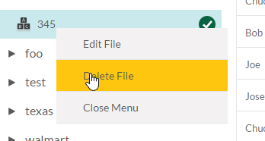
2. My Data will ask you if you’re sure you want to delete the file: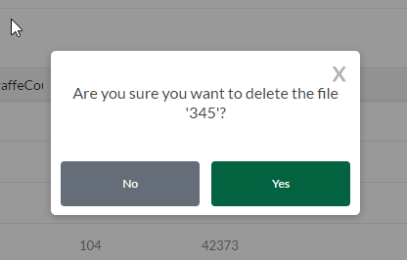
3. If you don’t want to delete the file, click No.
4. If you do want to delete the folder, click Yes.
5. After clicking Yes, the dialog disappears and My Data deletes the folder, but it will take a few moments for the folder tree to update. It will also take a few moments for the data to disappear from the data grid.

### Editing a file’s details with the context menu

1. Right-click the file name in the folder tree and click Edit File: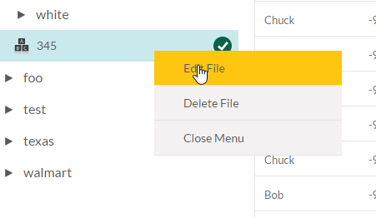
2. Here you can update the same details that you chose when uploading the file.
3. For points files, you can update the file name, icon, and icon color: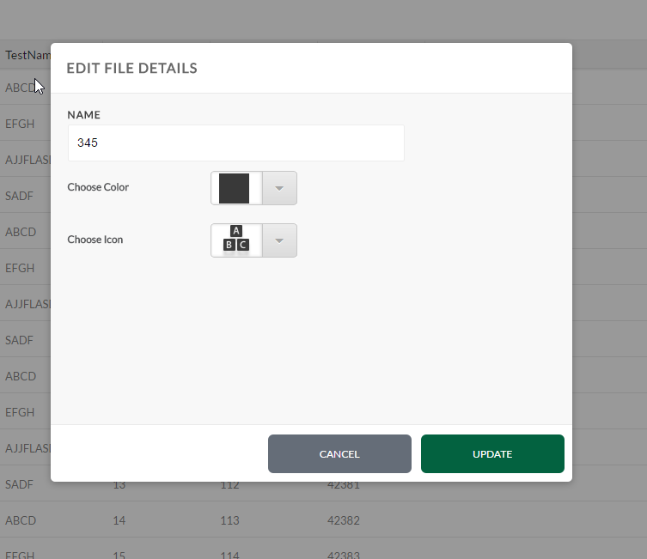
4. For polygon files, you can update the file name, color, and custom columns. Custom columns correspond to the “Optional columns” that you assigned (or chose not to assign) in the import process. These can be changed here. The options shown in the drop-down should be all the columns that exist in the file you uploaded: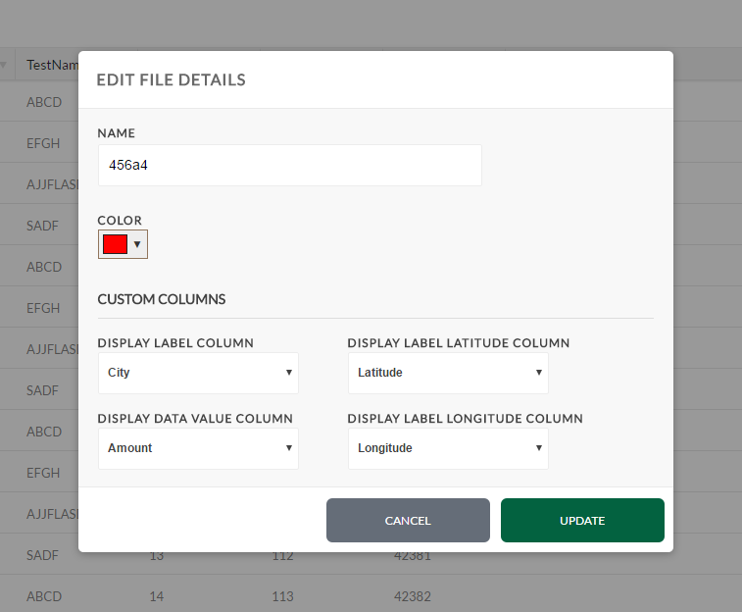
5. To cancel editing the file and not save any changes, click Cancel.
6. To save your changes to the file details, click Update. The folder tree and data grid should also update if you changed the file name or icon:

## Using the Folder Manager

1. Click Manage Folders:

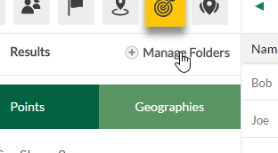

* 1. Note that if you had Points selected in the folder tree, you will be managing the points folder, and if you had Geographies selected in the folder tree, you will be managing the Polygons folder.

1. To open a folder, click the folder name:

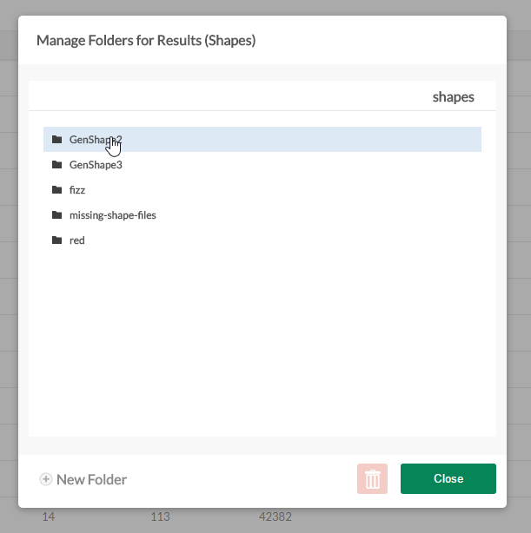

1. To delete a folder, open the desired folder and click the delete button:
   1. Note that this will delete the folder you are **currently in** – in the example screenshot, the folder “GenShape2” will be deleted:

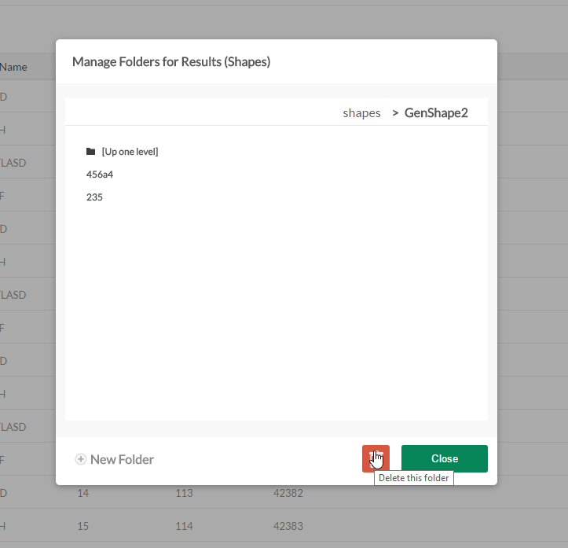

* 1. My Data will ask you if you’re sure you want to delete the folder, and will tell you whether or not it’s empty:

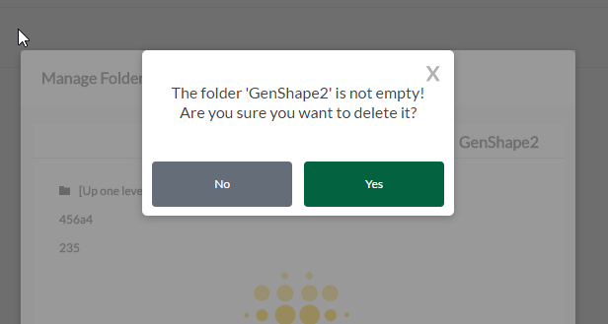

1. To delete a file, select the desired file by clicking its name: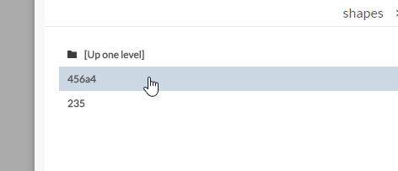
2. Click the delete button:

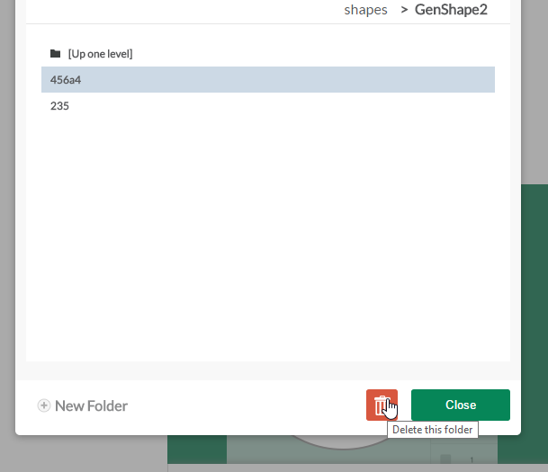

1. To create a new folder, make sure you are inside the parent folder that will contain the new folder:
   1. Click New Folder:

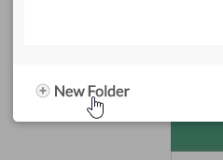

* 1. Type a name for the new folder:

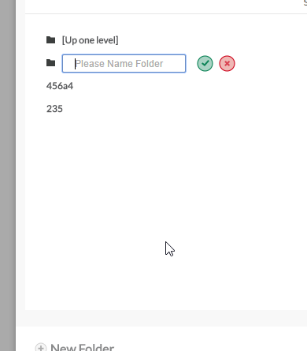

* 1. Press Enter, or click the submit button: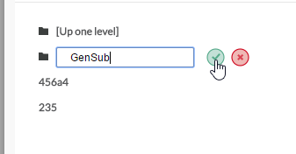
  2. To cancel creating a new folder, click the cancel button: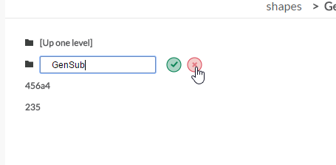

1. When finished managing folders, click Close:

